**﻿Conference site plan**

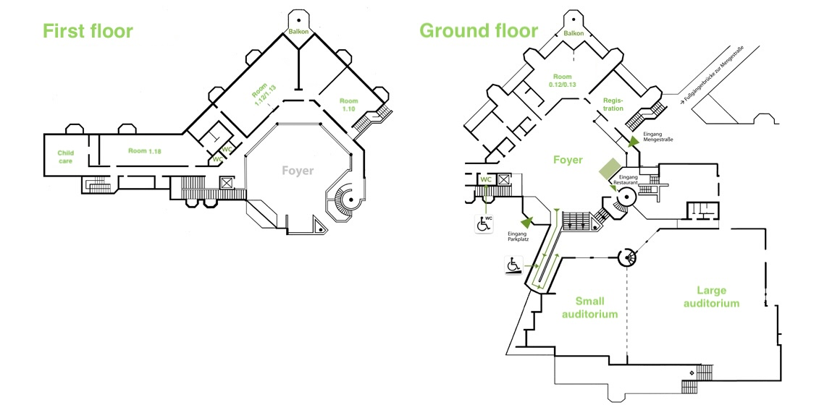

**How do I get to the venue?**

The Bürgerhaus Wilhelmsburg (Mengestraße 20, 21107 Hamburg) is just a 5-min walk from Wilhelmsburg train station that can be reached via S-Bahn lines 3 and 5 (from the city center in the direction of Hamburg Neugraben and Stade/Buxtehude, respectively). Trains leave every 5-10 minutes. The bus station Rathaus Wilhelmsburg is right next to the venue. Limited free parking is also available.

We recommend the [HVV-](https://www.hvv.de/de/app) and [Stadtrad](https://stadtrad.hamburg.de/)-Apps for getting around in Hamburg.

